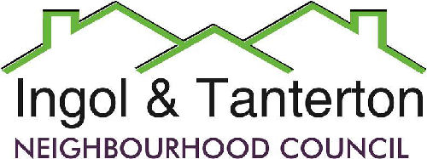

Agenda
A meeting of the Ingol and Tanterton Neighbourhood Council Finance Committee and TVC Liaison Committee will be held on Tuesday 25th August 2026 at 6.30pm at Tanterton Village Centre.

1.To receive apologies.

2.To receive declarations of interest and dispensations.

3.Public participation.

4.To consider the options for the Tanterton Village Centre management transfer and to resolve to put the chosen option as a proposal to full council.

Press and public are welcome to attend.

